Responsive Design Lab

# Intro

In this lab we will use Twitter Bootstrap to create a beautiful and responsive website like the one shown below.

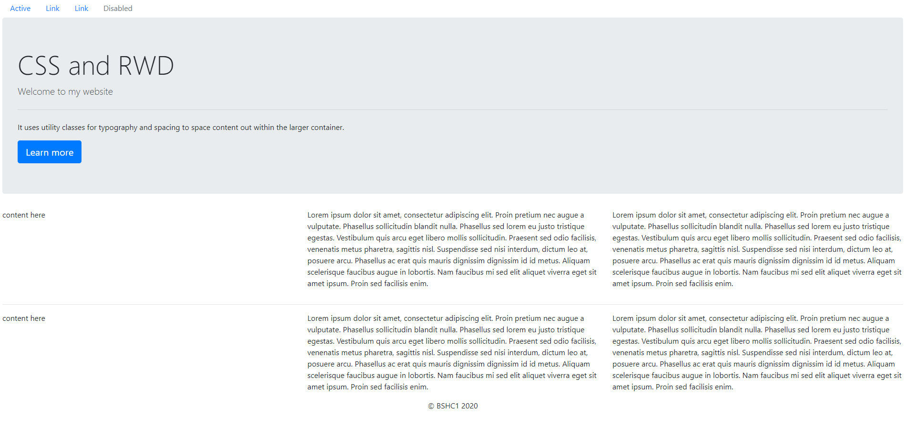

# Step 1

Create a simple website template (doctype, html, head, title, body)

Create a blank style.css file for your own CSS.

# Step 2

Navigate to: <https://getbootstrap.com/docs/4.1/getting-started/introduction/>

Copy the CSS line and put in your head section

Copy the JS lines. These can be put in the head or the body section.

# Step 3

Add the link to your own styles.css

# Step 4

Create a navbar by adding the following code:

<https://getbootstrap.com/docs/4.1/components/navs/>

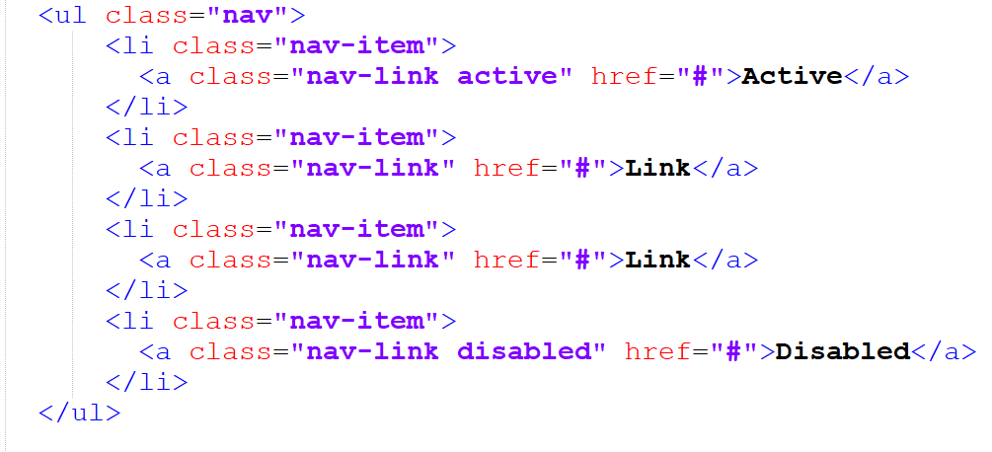

All of the classes you see above are Twitter Bootstrap CSS classes and take care of the position of the navbar as well as its font and colour.

# Step 5

Create a ‘jumbotron’ by using the following code:

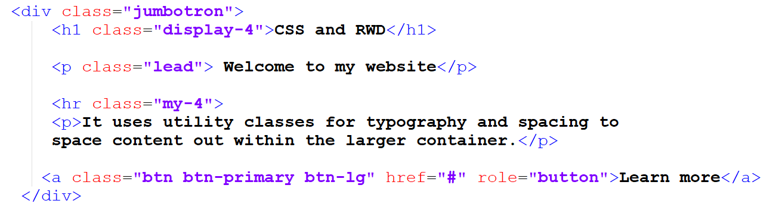

Change the text in the heading paragraph and button!

# Step 6

Create a ‘grid’ of content by using the following code:

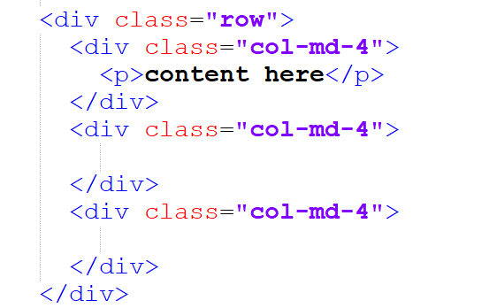

This creates a row with 3 identically sized blocks of content (4/12 columns wide each) Fill these sections with whatever content you would like.

Run the project as is.

Add in <hr>, what does that code do?

# Step 7

Create 2 more rows, with whichever layouts/content you would like. Remember for each row you need: container -> row -> cols

# Step 8

Create a footer by using the following code:

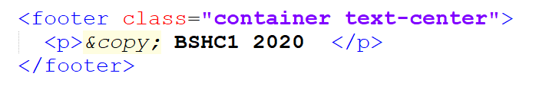

Add your own name and content into the footer.

# Advanced 1

* Create another html page (a copy of the first).
* Name it about.html
* Link to this new about.html from the navbar of the first page (Hint: <a href…>)
* Link from about.html to the first page (Hint: <a href…>)

# Advanced 2

Add a background image to the site using your own style.css

# Advanced 3

Change the color of the NavBar using your own style.css (Hint: use inspect element to figure out which css class controls the style of the navbar, then overwrite it in your own stylesheet)